**Premium Vs. Carrying Charge Market** An X-ray view of institutional orderflow barchart.com for commodities

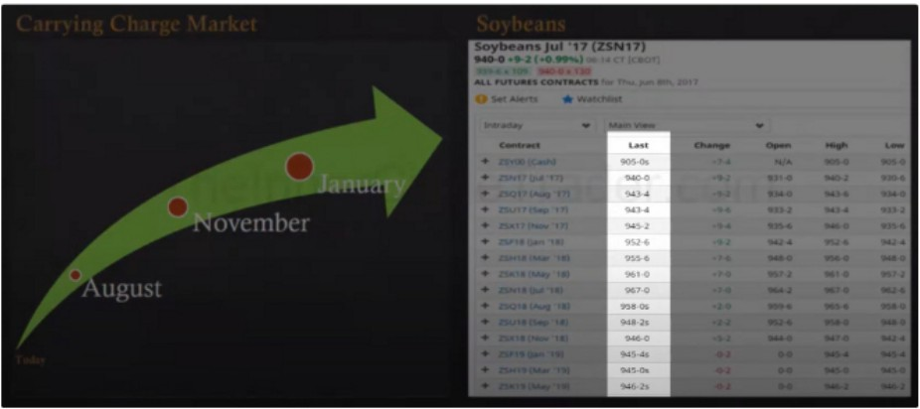

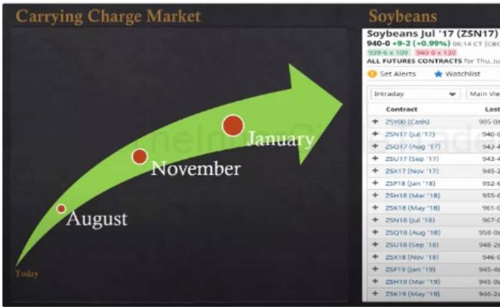

Were going to assume that the last is the closing price

The likelyhood of a parabolic move is far less likely to occur in a carrying charge market Nearby contract is the next month

Next month out is the month after the nearby contract

Premium market

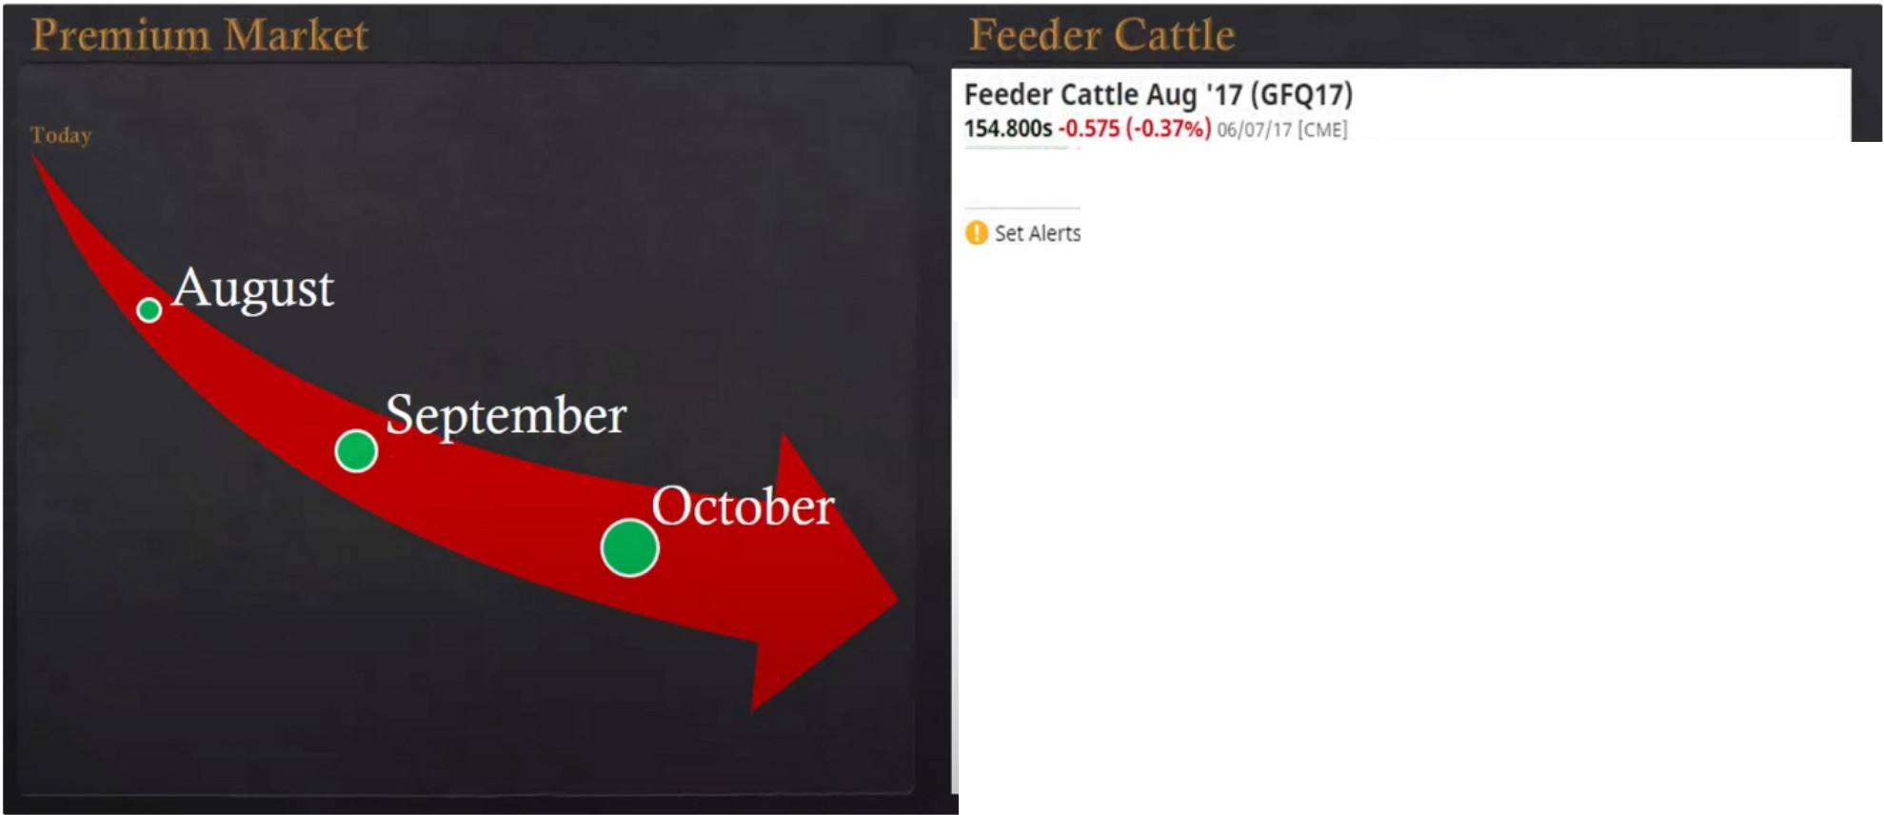

155.350 X 3 155.350x 4

**ALLFUTURES CONTRACTS for Thu, Jun 8th, 2017**

* watchlist

**lntraday**

.,

**Mam View**

.,

**Contract**

+ GFVOO (Cash)

+ GFQ17 (Aug "17)

+ GFU17 (Sep '17)

+ GFV17 (Oct '17)

+ GFX17 (Nov '17)

+ GFF180an '18)

+ GFH18 (Mar '18)

+ G 18 (Apr '18)

+ **GF1<18(May'18)**

**Last**

**Change**

Open

**High**

152.8105

* 0.220

**0.000**

152.810

**low**

152.810

**154.8005**

154.1255

152.TT5s

·0.575

-0.725

·0.225

154 725

153.750

152.300

156250

155.575

**154.000**

151.700

151350

150.050

151.275s

**145.3005**

**142.475s**

**•0.900**

**tl.025**

•0.975

149375

**142.800**

140.350

151.825

**145.750**

142.800

147.975

**142.000**

139.175

**141.675S**

1400

**141.150**

**141,800**

140.250

**140.nss**

**•1.400**

**0.000** 140.n5 140.n5

A premium market means theres something fundamentally strong about that particular commodity, The demand is high and the supply is short

If the price of the nearby contract is higher than the next month after it that is a premium market

This promotes the idea of a commercial bull market, that means that the commercials will be looking to take delivery of it right now immediately and they have to have it cause theres a short supply of it. So if theyre willing to pay a premium price on it now they know theres something fundamentally going on that they have to get the delivery of this commodity right now

I' I l 111111111 \ I ,II I.l I I ]\, ( .11 I I,

# 0June

# August

0

# october

0

**ALL FUTURES CONTRACTS for Thu.Jun 8th, 2017**

Set Alerts •watchhst

**lntraday** .. **Mam View** ..

**Contract** Last **Change** Open High

+ lFIOO (Cash) 136.3105 unch N/A 136.310

+ LEM17 Oun '17) 131.2005 **+1.000** 130325 132.325

+ LEQ17 (Aug '17) 124.1755 •0.575 123350 124.925

+ LEV17 (OC1 '17) 120.4005 •1.175 119.100 120.900

+ LE217 (Dec '17) 120.5255 **•1.000** 119.400 121.075

+ LEG18 (Feb '18) 120.8505 •1.075 **119.475** 121.250

+ LEJ18 (Apr '18) 119.2005 **•1.225** 117.675 119.500

+ LEM18 Oun '18) 111.875S **•1.050** 110.500 112.075

+ LEQ18(Aug '18) 1092005 •0.800 107.700 109.375

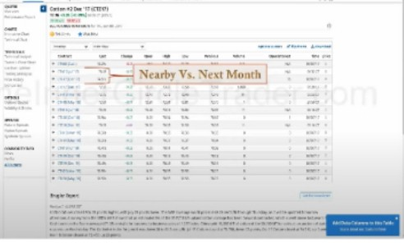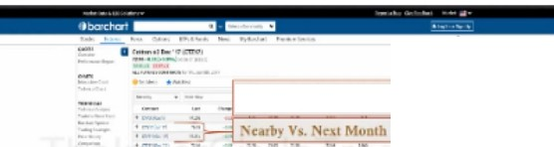

**Premium Market!** :=

Theres 2 kind of bull market

1. 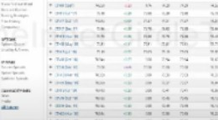Goes up gradually
2. Parabolic, vertical movement up

When a parabolic move happens its usually based on a premium market

Premium markets have the tendency to move really quick in a short amount of time

|  |  |  |  |  |  |  |  |  |
| --- | --- | --- | --- | --- | --- | --- | --- | --- |
| **0 Op:75.90, Hi:76.** | **39, Lo:75.** | **80,0:76.09** | | | | | | **88.00** |
| **e ar y y**  i  +Ill+  *\ 1,)* | | | ... |  | **ac** •  •1  ' | **'+1** I"**1!. t** | '•+ | **87.00** |
| **86.00** |
| **85.00** |
| **84.00** |
| **83.00** |
| **82.00** |
| **8l00** |
| **80.00** |
| **79.00** |
| **78.00** |
| **n.oo** |
| **ml** |
| 75.00 |
| 74.00 |
| 73.00 |
| 72.00 |
| 71.00 |
| 70.00 |
| **.linl7 Feb** | | |  |  | **Apr** | Illy **Jun** |  |  |

We look the same at commodities as we look at currencies etc in the form of technicals Do not confuse commodities premium with premium and discount PD arrays

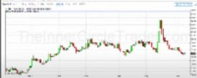

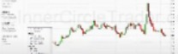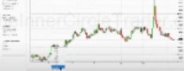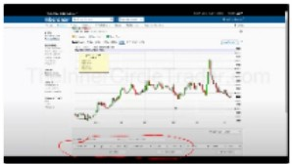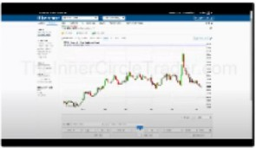Spread chart is the difference plotted between the nearby contract and the next month out At minute 11, tutorial on how to set it up

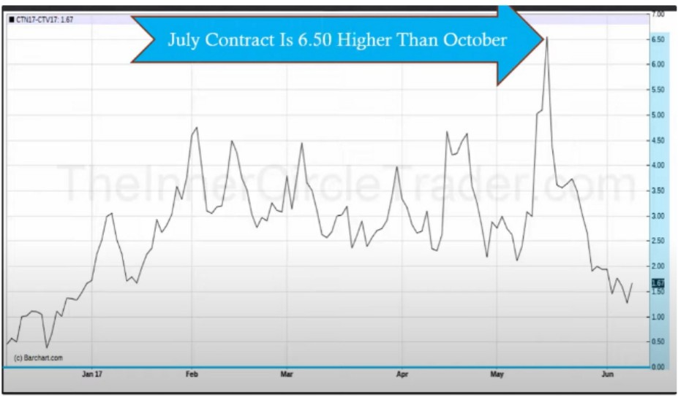

.!!I

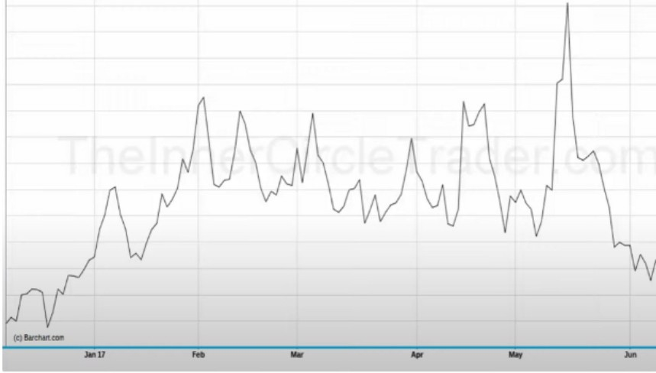Anything above the O line is the spread that the nearby contract is trading above the next month out The larger the spread the stronger and more likely a commercial bull market is or a parabolic move

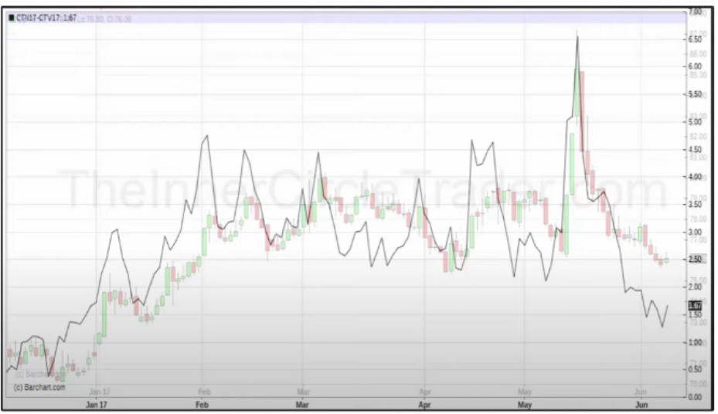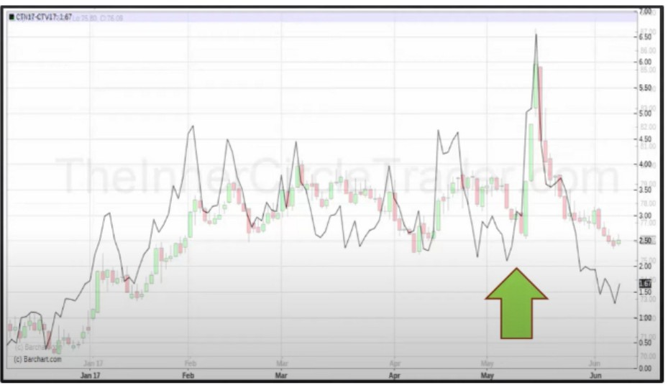

Look at the month may, we had bullish divergence between the spread line and the chart We want to look for bullish divergence of the nearby contract and the spread

That divergence is a buy signal

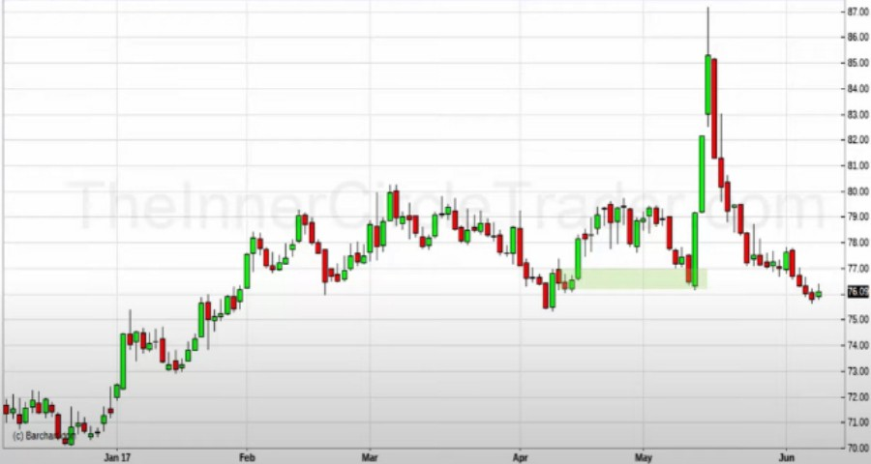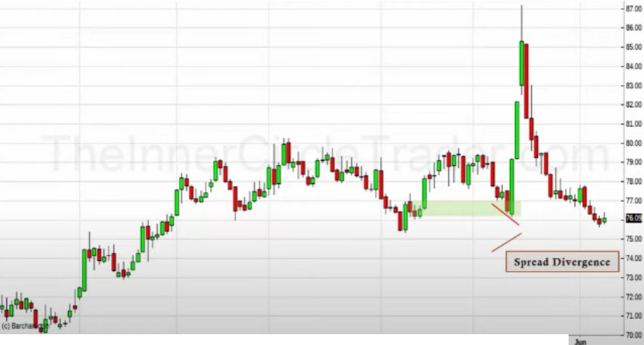

Cotton was bullish, were in a discount range at a bullish orderblock in a market where cotton is showing a premium. High probability

Divergence is only being shown when commercials are stepping in and buy quickly with massive amounts

These things happen every single year, these things are what makes commodity trading fun Spend time looking at the "fundamental" then we can frame a real strong buy

This repeats itself in an opposite framework, when theres a premium market. If the market makes a higher high but it does so with a lower peak in the spread that does not promote commercial buying, take that with a grain of salt. You want to see the spread increase with the price

In ICTs opinion fundamentals are needed for commodities because they are tangible real things, its the worlds grocery store

Now we have a way of framing institutional buying and selling and we know when theyre going to do it with explosive moves

Arjo I Twitter, lnstagram I Linktree

Linktree. Make your link do more.

, https://t.co/HhmmTN1fUI

JavaScript is not available.

'If# https://twitter.com/arjoio